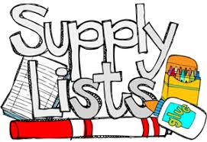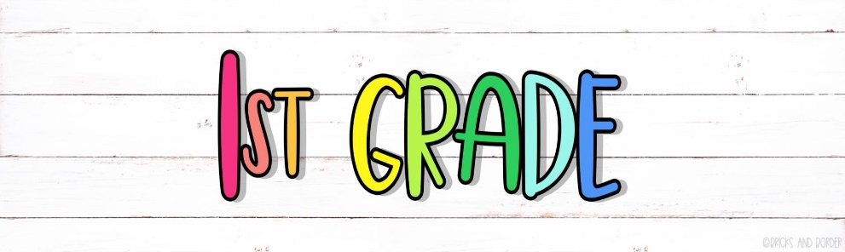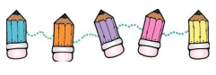

* Headphones (Please NO ear buds)
* 2 jumbo glue sticks
* 1 Elmer’s liquid glue

Wishlist

* Band-aids
* Gloves
* Paper towels
* Printing paper
* Cardstock paper
* Baby wipes
* Galloon Ziploc bags
* Fun Friday Snacks (for the class)
* 2 boxes of Crayola crayons (24 pack)
* 2 packs of pencils
* 1 plastic pencil box/case
* 1 spiral wide rule notebook
* 2 packs of wide rule paper
* 2 boxes of Kleenex
* 1 bottle of hand sanitizer
* 1 pack of 3x5 index cards
* 1 pack of dry erase markers
* 1 kid scissors
* Playdoh
* 1 plastic folder with prongs
* ½ inch or 1inch binder (Clear plastic cover on the front and pockets)
* 2 pink erasers
* 1 spill proof water bottle

***Please write your child’s name on all supplies.***

Thank you, parents, for your support in making sure your child is equipped for the school year! 😊

